Writing for Wellness
A mental health creative writing group
All Welcome, Free Refreshments
Mondays starting Jan. 13th, 2020 @ 2:30 pm
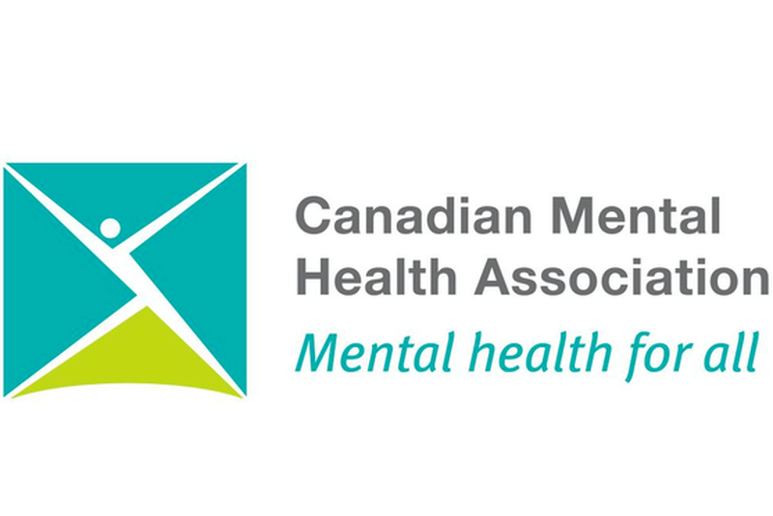
Location: 386 Queen St E. (Boardroom)

Questions?
Call: 705-759-5989

