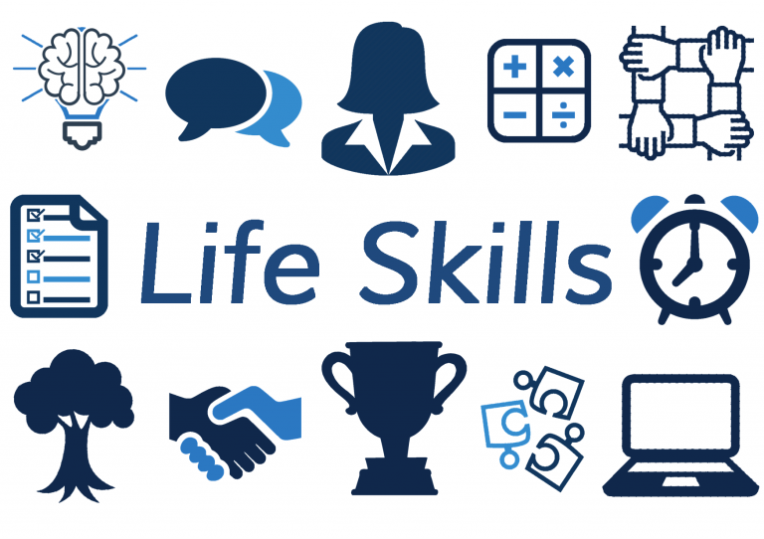

Life Skills: “A skill that is necessary or desirable for full participation in everyday life”.
Friday’s starting Friday January 17th 2019 from 1:00PM-3:00PM
All are Welcome!
Location: Soup Kitchen Community Centre
172 James Street
Questions? Call: 705-759-5989

