Dates: **January 25, 26 2018**

Time: **9:00 a.m. to 4:00 p.m.**

Location: **386 Queen Street East**

***Limited to 25 participants **$150.00**

To reserve your spot please call or email

[lisa@cmhasmms.com](mailto:lisa@cmhasmms.com)

705 759-0458 ext. 231

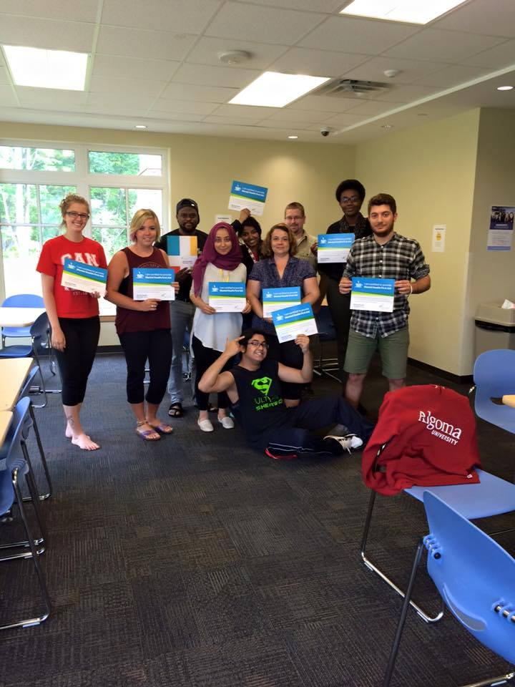

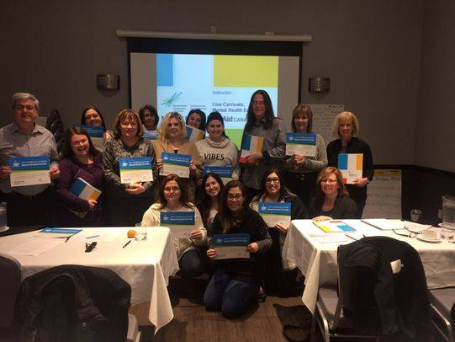

Don’t miss this interactive **2 day** training! Taught by local Instructor Lisa Carricato. She works as the Mental Health Educator for CMHA Sault Ste. Marie and is a Certified Instructor with The Mental Health Commission of Canada. Her years of experience and knowledge of local services brings this course to life! Proceeds from the training go back to CMHA SSM to provide free services to the community.

Participants who attend the entire workshop will receive a manual and a **certificate** from The Mental Health Commission.

The fee is only **$150.00** and coffee and a light lunch is provided.



**MHFA Basic** is intended for adults interacting with adults (18 years and older). This course focuses on the four most common mental health disorders including substance related, mood related, anxiety and trauma related, and psychotic disorders. Participants who take this course are well prepared to interact confidently about mental health with their family, friends, communities, and workplaces.

**Key Outcomes**

International evaluations and feedback have found the following outcomes for participants undertaking an MHFA course:

* Increased awareness of signs and symptoms of the most common mental health problems
* Decreased stigma related to mental health
* Increased confidence interacting with individuals experiencing a mental health problem or crisis
* Increased help actually provided to individuals in crisis or experiencing a mental health problem

