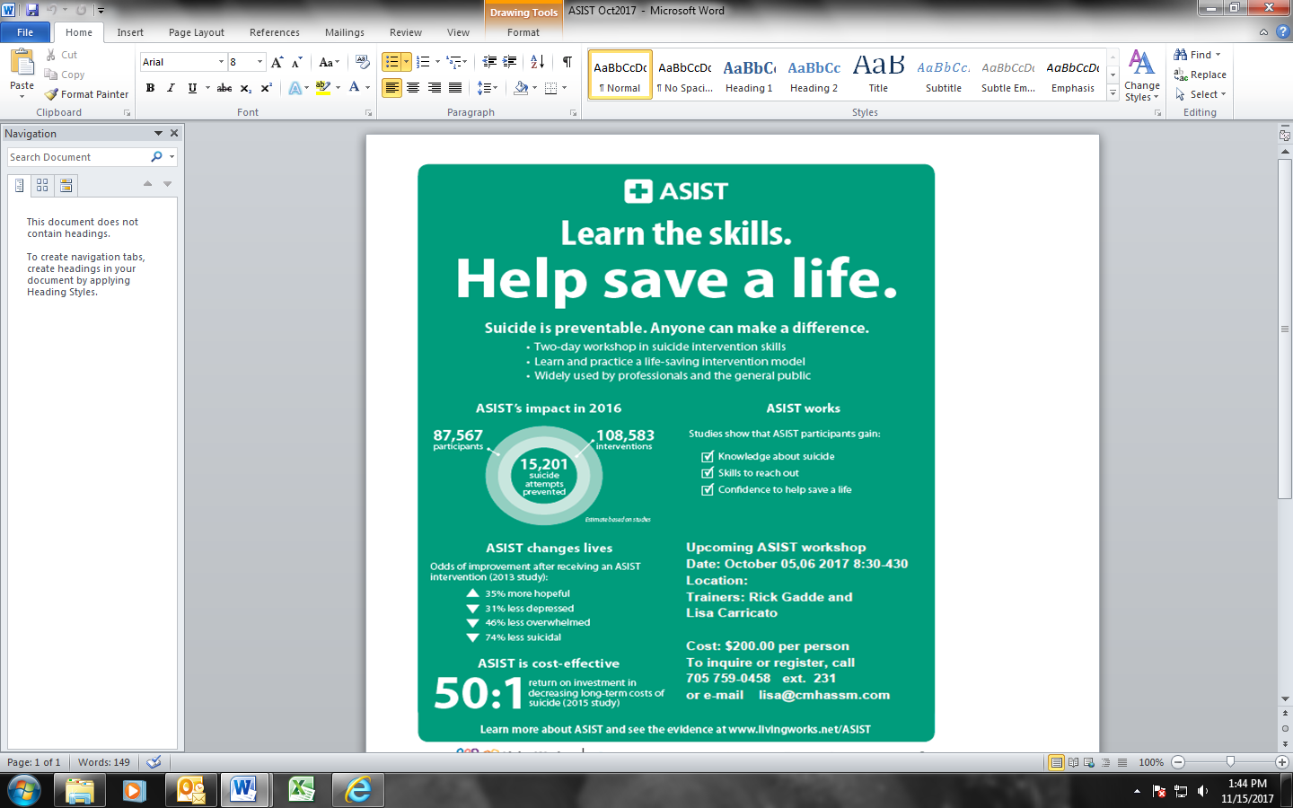

**Note:**

**Deposit is non-refundable**

Your registration constitutes your commitment to attend the workshop. You may substitute another person in the event you cannot attend.



**Past participants of this program have consistently rated the workshop as…**

**“Absolutely Essential”,**

**A “10”**

**“Your training saved a life…thank you”**

**In both their work and their life, while achieving a greater understanding of suicide ideation.**

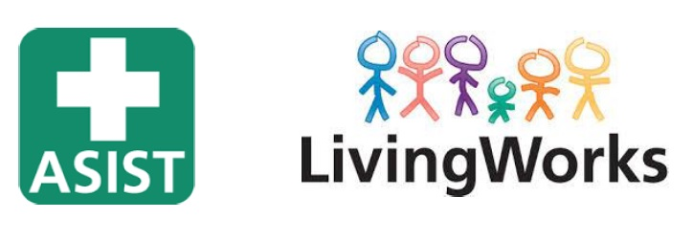

**2 Day Workshop**

Mark your calendars and register for training in the **most widely utilized model of Suicide Intervention in the world.**

Completion of this training provides you with a **Certificate.**

*Total of 15 Hours*

**January 13 , 14 2018**

**8:30 -4:30 both days**

**Location: Sault College**

**Enji Maawnjiding**

**Course Fee  
$200.00**

* $50.00 Deposit Required with Registration

To Register contact:

**Lisa Carricato**

[lisa@cmhassm.com](mailto:lisa@cmhassm.com)   
(705)759-0458

ext 231

**Applied Suicide Intervention Skills Training**

