**May, 2018**

**20182018**

**Promote Mental Health in Your Workplace**

**Mental health in the workplace affects us all, whether we are employers or** **employees.** When mental health issues are not addressed and treated appropriately, there can be considerable personal and financial costs to both individuals and organizations. Fortunately, with prevention, early treatment and support , many of these costs can be significantly reduced or eliminated entirely. Forward thinking organizations have already begun to focus on what they can do to support the mental health of their employees. Given predictions that depression will be the second leading cause of disability by 2020, we can expect mental health in the workplace to be a key management issue for many years to come.

**Did you know?**

* 10-20% of Canadian youth are affected by mental illness.
* 1 in 5 Canadians will experience mental illness. 2 in 3 people suffer in silence fearing judgement.
* Up to 70% of young adults living with mental health problems report that the symptoms started in childhood.
* Suicide is among the leading cause of death in 15-24 year old Canadians, second only to accidents.
* Mental illness is NOT a form of weakness. You CAN recover from mental illness

REASONS TO IMPROVE WORKPLACE MENTAL **HEALTH**

Calendar**500,000**Canadians, in any given week, are absent from work due to mental health problems.

Notepad**1 in 3** workplace disability claims are related to mental illness.

Money**70%** of disability costs are attributed to mental illness.



**Certified Trainings**

**\*\*\*All Certified Trainings include resources and training materials and participants receive a certificate upon completion \*\*\***

**ASIST Refresher** (for those who have been trained in ASIST)

Like First Aid and CPR – ASIST trained caregivers need a refresher to stay current and review the skills learned in their 2 day training. We recommend that caregivers complete this refresher every 2-3 years. This **half day training** will help caregivers to feel comfortable, confident and competent in intervening with a person who is at immediate risk of suicide.

**$50.00 per person**

**Applied Suicide Intervention Skills Training (ASIST)**

This **2-day (15 hours)** workshop is for anyone who wants to feel more comfortable, confident and competent in helping to prevent the immediate risk of suicide.

Almost a million caregivers have received this training. Just as “CPR” skills make physical first aid possible, training in suicide intervention develops the skills needed for suicide first aid.

ASIST is an intensive, interactive and practice dominated course designed to help caregivers recognize risk and learn how to intervene to prevent immediate risk of suicide.

**$220.00 per person**

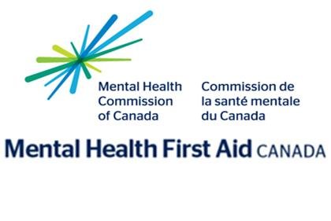

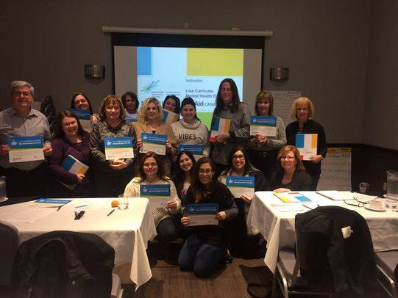

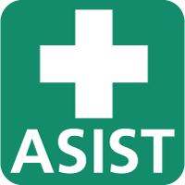



**Mental Health First Aid**

Mental Health First Aid (MHFA) is the help provided to a person developing a mental health problem or experiencing a mental health crisis. Just as physical first aid is administered to an injured person before medical treatment can be obtained, MHFA is given until appropriate treatment is found or until the crisis is resolved. The program does not teach people how to be therapists. It does teach people how to:

Recognize the signs and symptoms of mental health problems.

Provide initial help.

Guide a person towards appropriate professional help.

This **2 Day training** provides participants with a better understanding of mental health, mental health challenges and where help is found in the community.

**$150.00 per person**



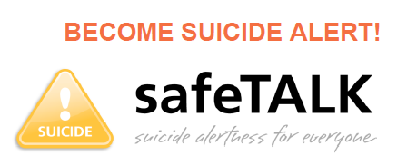

**safeTALK**

safeTALK is a **3 hour** training that prepares anyone over the age of 15 to identify persons with thoughts of suicide and connect them to suicide first aid resources. Most people with thoughts of suicide invite help to say safe – this training teaches people to recognize what those invitations to help may be, to ask directly about suicide and to help a person keep safe.

**$50.00 per person**

**Wellness Works…**

**Improving Workplace Mental Health**

**Our Wellness Works education suite provides the workshops, courses and presentations your workplace needs to help your team learn more about mental health. Your staff will learn to improve their own wellness, manage stress and support others living with mental health concerns.**

**And here’s the good news – every $1 that businesses invest in mental health returns $2.30 in improved productivity. A mentally healthy workplace is worth investing in.**

**We have several workshops and programs to choose from and we can provide customized sessions based on your unique needs and timeframe. We can be flexible and offer evening/weekends if need be**.



[**Stress Essentials**](http://cmhapeeldufferin.ca/education-and-training/wellness-works/stress-essentials/)

**Stress can have a detrimental effect on the health and wellbeing of employees, as well as a negative impact on productivity.**

**Learn to recognize signs and symptoms of stress as well as simple but effective tools and strategies to manage stress.**

**1 Hour: $150.00**

**(A popular Lunch and Learn Option)**

[**Mental Health 101**](http://cmhapeeldufferin.ca/education-and-training/wellness-works/mental-health-101/)

**Improve mental health awareness and psychological health and safety in your organization.**

**Mental Health 101 provides employees with an understanding of various mental health issues, builds mental health awareness and helps reduce the stigma associated with mental illness. Participants will learn strategies for maintaining their mental wellness and for providing compassionate support and understanding to colleagues, friends and family**.

**1 Hour: $150 / 3-hours: $400.00**

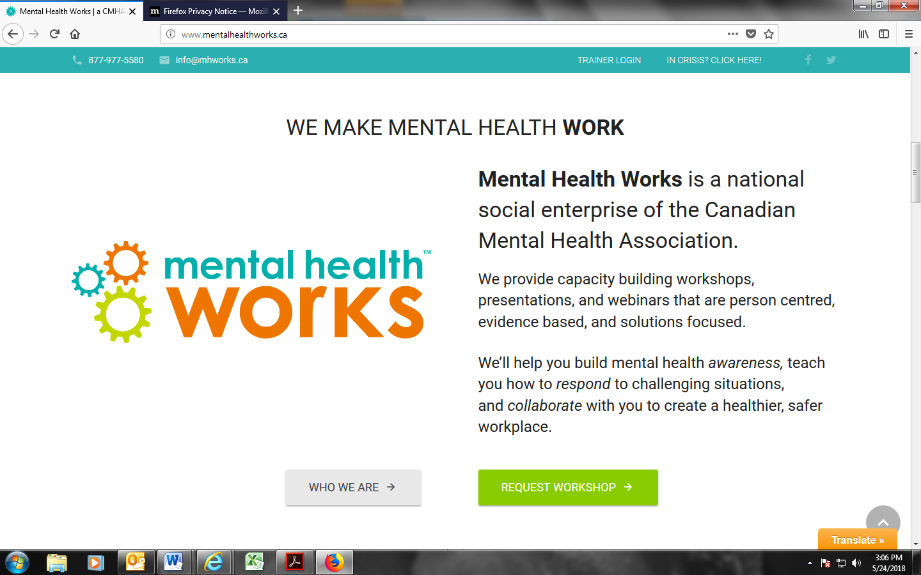

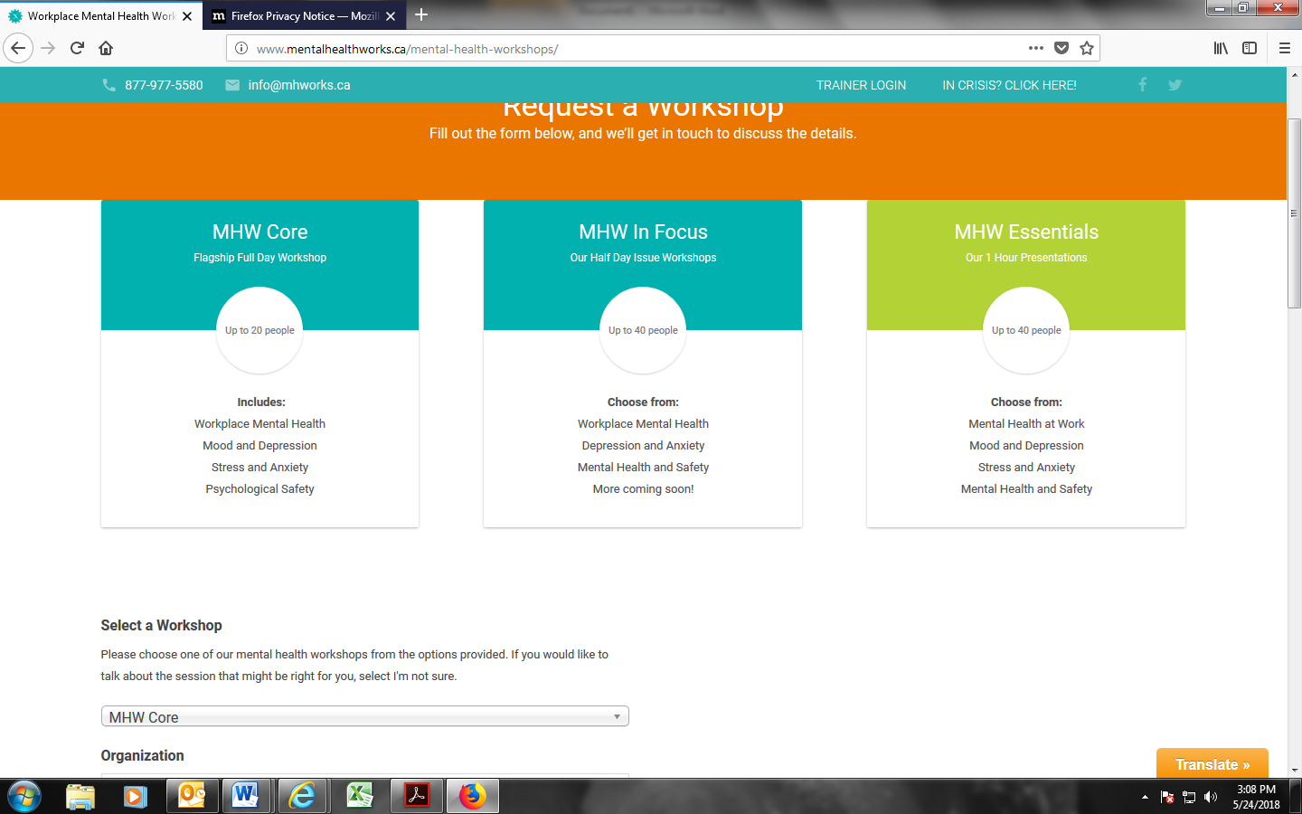

**The good news is that mental illnesses are treatable. Early recognition of mental health problems, referrals to the right resources (such as Employee and Family Assistance Plans), and adequate treatment can help people get on the path to recovery and go back to their usual work quickly. Employees can and do reach their full potential when they have the right supports in their life, including those at their workplace. Some mental health problems in the workplace can also be prevented when organizations take steps to create mentally healthy workplaces for all employees.**

**CMHA National**

**$400.00**

**$150.00**

**$800.00**



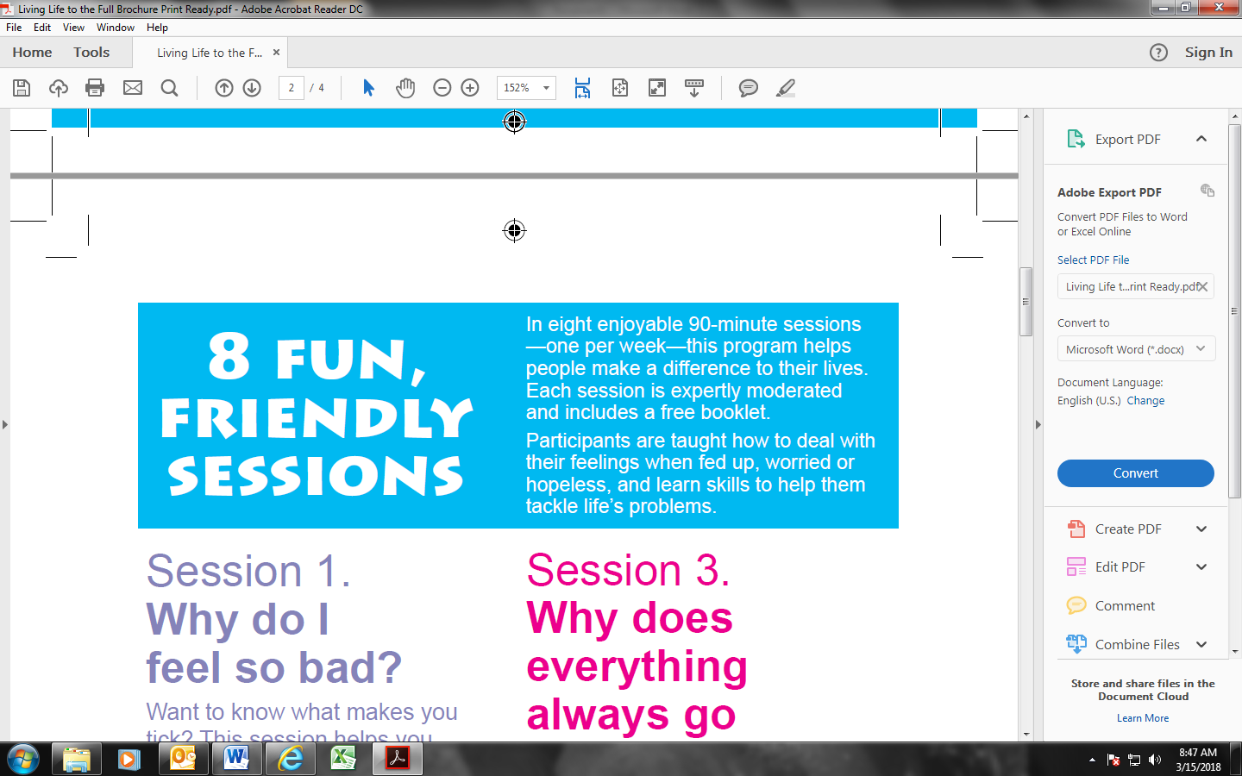





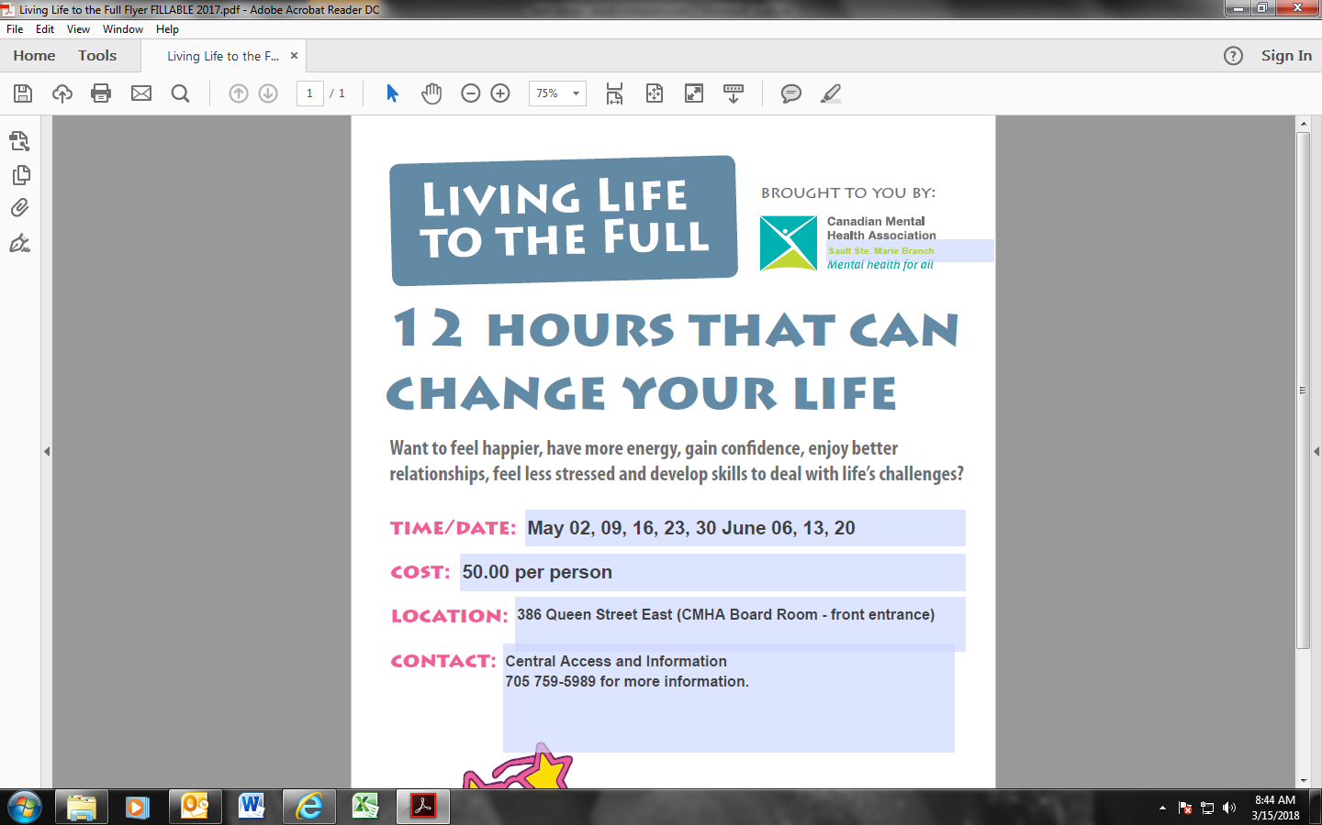

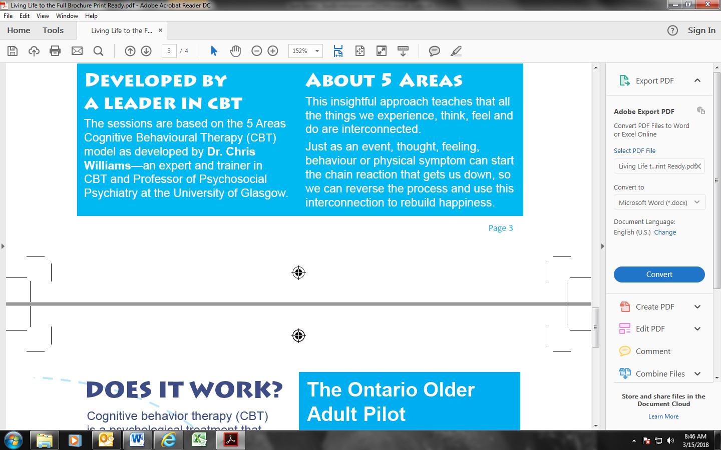

**Workshops**

**Did you know…**

**By booking your training with CMHA Sault Ste. Marie, proceeds go directly back to your local Branch and help provide services to our community…**

**If you have any questions or would like us to custom develop training for your organization please contact:**

**Lisa Carricato, Mental Health Educator**

[**lisa@cmhassm.com**](mailto:lisa@cmhassm.com)

**(705)759-0458 ext. 231**

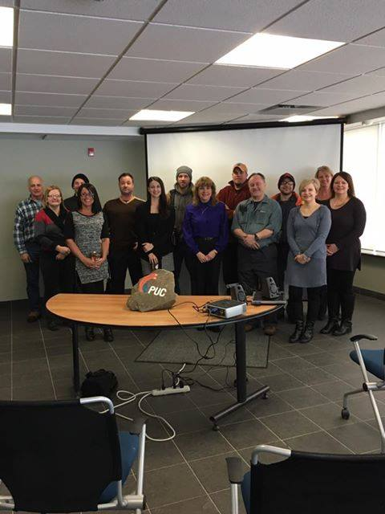

[**Dealing with Challenging People**](http://cmhapeeldufferin.ca/education-and-training/wellness-works/dealing-with-difficult-people/)

**Change the way you see and respond to difficult situations and learn to handle difficult conversations with skill and confidence.**

Learn strategies to recognize mental health concerns and address various behaviours (e.g. verbal aggression, negative talk, sense of entitlement, safety). Learn valuable skills and methods to change the dynamic, de-escalate and support individuals and groups.

**3 Hours: $400.00**