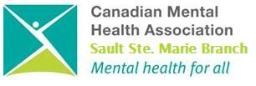

*Total of* ***15 Hours***

**Course Fee  
$200**

( includes training material and light lunch )

Location: **Grand Gardens North**

(1324 Great Northern Rd)

* Coffee and lunch provided

**TO REGISTER  
CONTACT**

**CMHA Central Access   
(705) 759-0458 ext. 231**

**Or by e-mail lisa@cmhassm.com**

**2 Day Workshop**

April 2 -  
**Thursday October 05 and Friday October 06 2017**

**8:30 - 4:30 (both days)**

Mark your calendars and register for training in the most widely utilized model of Suicide Intervention in the world.

Completion of this training provides you with a certificate.

**Note:**

Receipts will be provided at the workshop or, if requested, sent to you immediately.

Your registration constitutes your commitment to attend the workshop. You may substitute another person in the event you cannot attend.





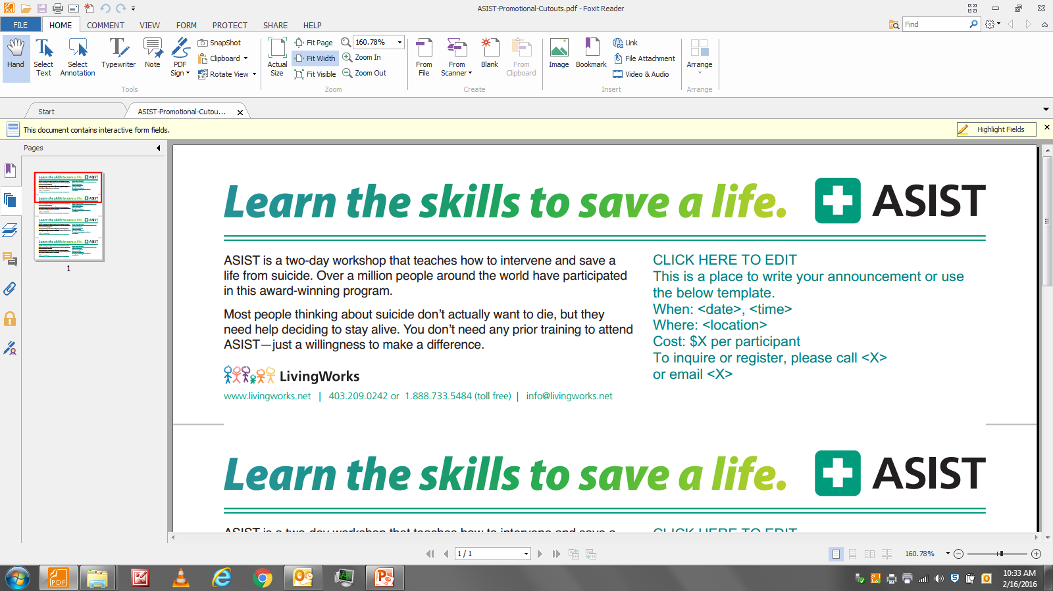

Past participants of this program have consistently rated the workshop as…

“Absolutely Essential”,

A “10”

“Your training saved a life…thank you”

In both their work and their life, while achieving a greater understanding of suicide ideation.

**Applied Suicide Intervention Skills Training**